|  |  |
| --- | --- |
| **Exp No: 4**  **Date: 23.2.25** | **HELLO WORLD IN SERVLET** |

**AIM:**

To create a web form that accepts a user’s name and age and to write a servlet to process the form data and display it back on the browser

**PROGRAM:**

**User.html**

<!DOCTYPE html>

<html>

<head>

<meta charset=*"ISO-8859-1"*>

<title>LOGIN</title>

</head>

<body>

<h1>Hello User!!</h1>

<form method=*"GET"* action=*"/ROHIT_191/user_validate.jsp"*>

<p>

<label>Name:</label>

<input type=*"text"* name = *"name"*/>

</p>

<p>

<label>Age:</label>

<input type=*"number"* name = *"age"*/>

</p>

<input type=*"submit"* value=*"submit"*/>

</body>

</html>

**User_validate.jsp**

<!DOCTYPE html>

<html>

<head>

<meta charset=*"ISO-8859-1"*>

<title>DETAILS</title>

</head>

<body>

<%

String a = request.getParameter("name");

**int** b = Integer.parseInt(request.getParameter("age"));

%>

<h1>Find your details</h1>

<p>Username:<%=a%></p>

<p>Age:<%=b%><p>

</body>

</html>

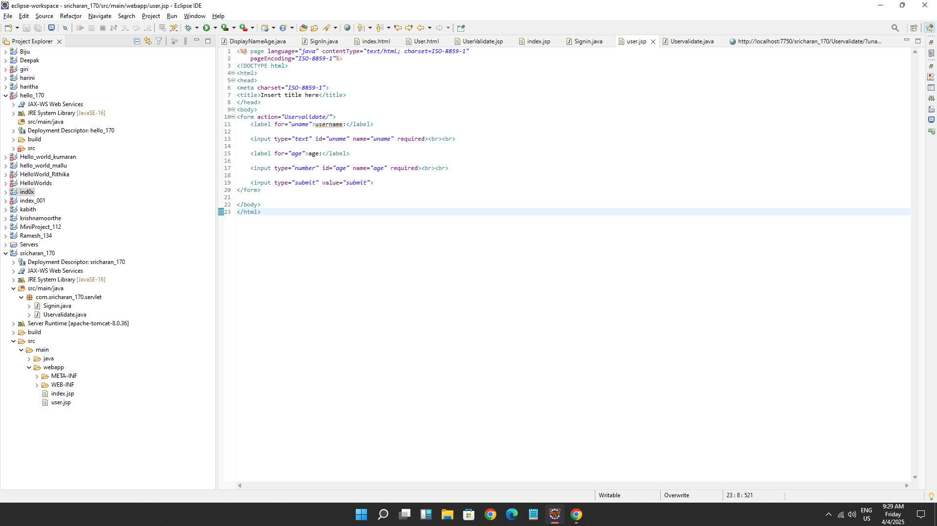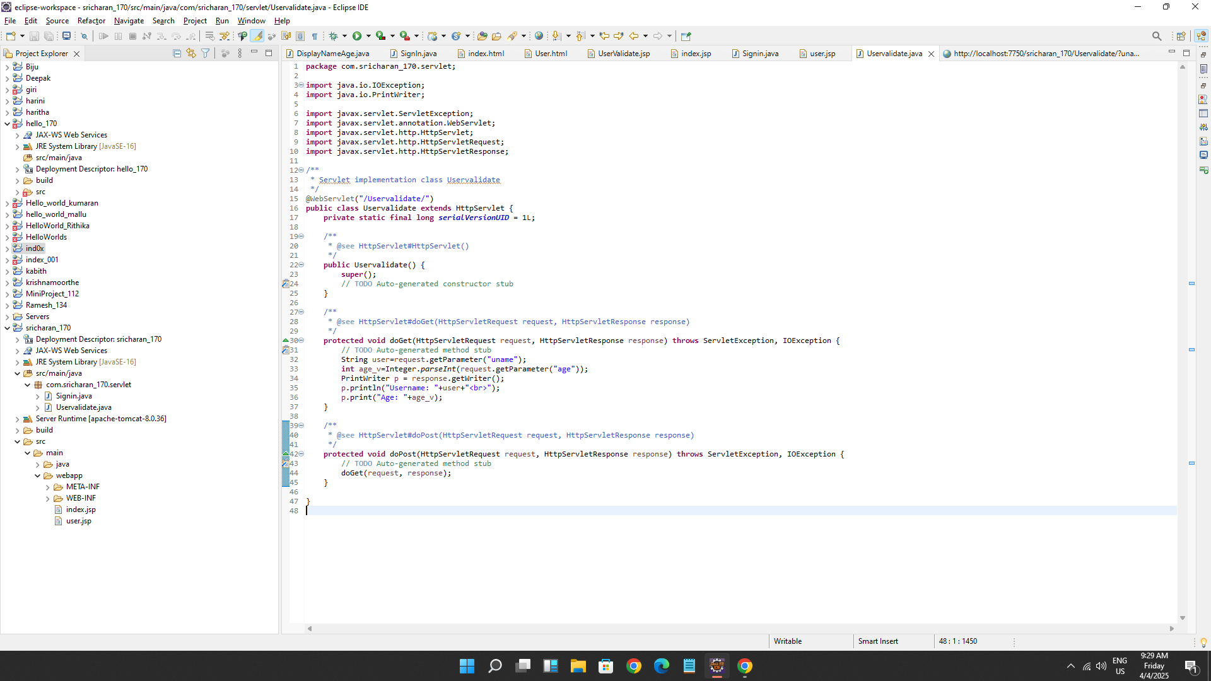

**OUTPUT:**

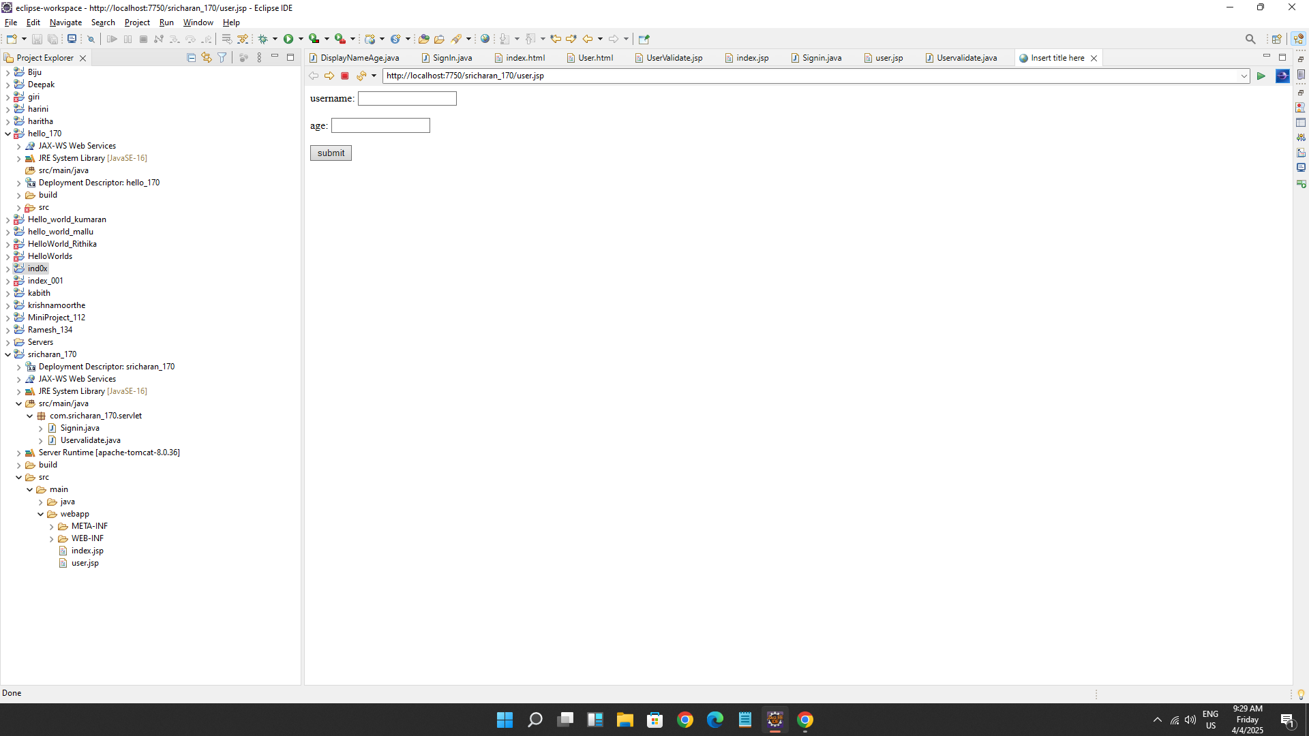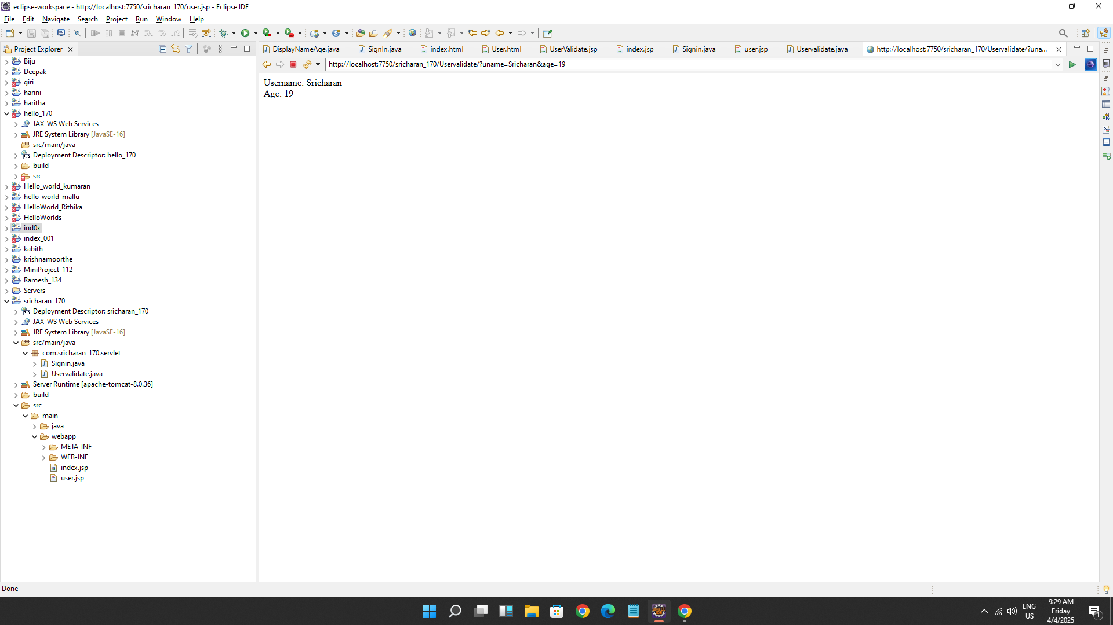

**RESULT :**Thus the create a web form that accepts a user’s name and age and to write a servlet to process the form data and display it back on the browser has been implemented and verified successfully.